Supersedes SN 401-1: 2010-03

Table of contents
Page
- Scope 1
- Normative references 1
- General specifications 1
- Access to the danger zone, door safety categories 2
- Fence and door elements, terms and definitions 2

Normative references
SN 401-2 Safety provisions for danger zones – Fence elements
SN 401-3 Safety provisions for danger zones - Door elements/door units
SN 401-4 Safety provisions for danger zones, electric door interlocking, design directive

General specifications
The specifications are based on hazards caused by moving machine parts or by material. If an equipment presents other hazards, it shall be checked for each particular case whether it is permitted to use the fence elements defined in this standard and, when necessary, the fence elements shall be replaced with suitable guards or such guards shall be used in addition to the fence elements.
The fence and door elements used shall be 1400 mm or 2200 mm high, intermediate heights are not permitted. Fence systems according to SN 401 can only be used at one level. When differences in level have to be provided with protective fences, the necessary elements shall be tailored for the particular application.
According to DIN EN ISO 13857, fences shall be installed at a defined minimum horizontal distance from a point of possible hazard located within the danger area behind the fence to prevent reaching of this hazard point (see Fig. 1). If it is not possible to comply with the minimum distances stated in Table 1, other solutions shall be implemented which are specifically tailored for the case of hazard taking into account the stipulations made in DIN EN ISO 13857 and
DIN EN 349.

Table 1 - Dimensions

Height of hazard point a | Height of protective device b
Height of hazard point a | 1400 | 2200
Height of hazard point a | Horizontal minimum distance from hazard point c
- a) | ≥ 1100 | ≥ 400
a Height of hazard point according to application

Page 2
SN 401-1: 2011-08

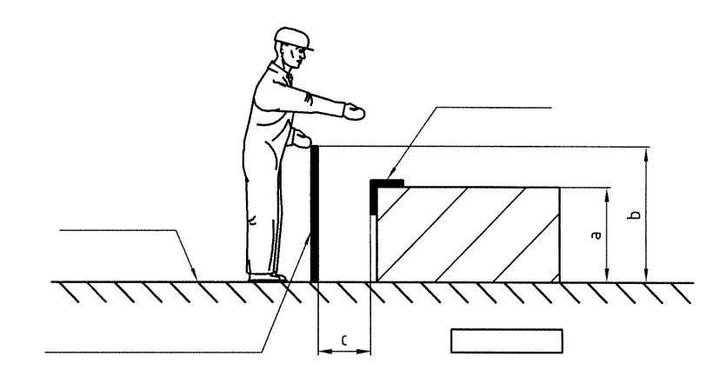
Hazard point
Reference level
Protective device/fence
Danger zone
a = height of hazard point
b = height of protective device
c = horizontal minimum distance

Fig. 1 – Danger zone

Access to the danger zone, door safety categories
The fence system specified in the SN 401 set of standards uses different safety categories for access to the danger zone. On the basis of risk assessment according to SN 114 and with due regard to the requirements made in DIN EN 953, the safety categories applicable to the access doors shall be determined for access to the different equipment areas and danger zones. The different safety categories impose different safety devices which shall be installed without exception on every access door leading to the danger zone.
There are two safety categories for the access doors:

Safety category T I:
The safety device is purely mechanical (key, lock) and there is no connection with the control systems. Access to the protected area is possible for authorised persons (lockable doors). Warning signs according to SN 118 shall be provided in the door area.

Safety category T II:
The safety device is connected with the control system (safety door), different designs of the electric safety devices are possible. Access to the protected area is possible only after the equipment has been brought to a safe operating condition. The doors are secured by electric guard locking or key transfer system. The escape unlocking mechanic of doors of safety category T II, height 1400 mm, shall be provided with a suitable guard to avoid actuation of the mechanism by reaching over the fence from outside. Type and construction of this guard are left to the discretion of the specialist company. Warning signs according to SN 118 shall be provided in the door area.

Fence and door elements, terms and definitions
A distinction is made between fence elements and door elements:
- Fence element is the general term for all fence nettings and fence posts (see Fig. 2). The fence elements stated shall be used for both safety categories. Fence posts can also be ordered as complete units with all necessary fastening elements.
Door element is the general term for all individual elements used to make up wing door units and their posts (see Fig. 2). The door elements have different designs for safety category T I (mechanical lock) and category T II (electric guard interlocking/key transfer system). All components required for category T II are specified in SN 401-4.

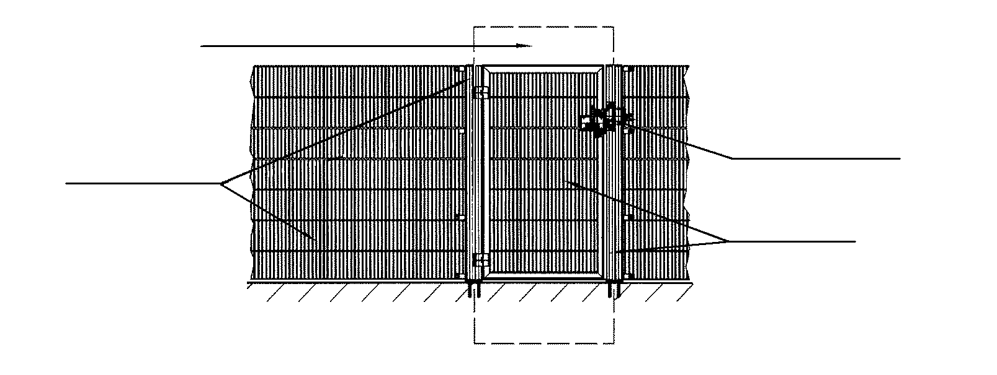
Door unit
Electric guard locking
Fence elements
Door elements

Fig. 2 – Individual elements

Page 3
SN 401-1: 2011-08

Referenced technical standards, codes and regulations
DIN EN 349 Minimum gaps to avoid crushing of parts of the human body
DIN EN 953 Guards; General requirements for the design and construction of fixed and movable guards
DIN EN ISO 13857 Safety of machinery; Safety distances to prevent hazard zones being reached by upper and lower limbs
SN 114 Plant safety; Plant-related risk assessment; Risk graph SN 118 Safety layout; symbols

.

